Philadelphia University  Lecturer : Soha Telfah  Coordinator :  Internal Examiner : |  | Faculty of Pharmacy  Department of Pharmaceutical science

Student Name: Student Number:
Course Name: Phytochemistry First Semester of Academic Year 2009/2009
Course Number: 540302
Section: 1 Date: 27/12/2010
First/Second/Final Exam Duration of Exam: 1 hour

Information for Candidates
1. This examination paper contains 2 questions in 7 pages, totalling 25 marks.
2. The marks for parts of questions are shown in round brackets.

Notes to Candidates
1. You should attempt all questions.
2. You should write your answers clearly

Part I. Basic Notions
Objectives. The aim of the questions in this part is to evaluate the required minimal student knowledge and skills. Answers in the pass category represent the minimum acceptable standard (10 marks).
Q.I. Fill the following table with suitable answer in B in correspondence to column A:

 | A | B
1 | Tubucurarine is water soluble for the following reasons | 1-  2-  3-
2 | Di hydroIndole moiety essential for the activity of vinca alkaloid
3 | Quinine alkaloid is the stereoisomer for … .alkaloid
4 | Natural opoid in human, concentration in female higher than male.
5 | Alkaloid used for dry cough; with central  Devoid of any addiction or respiratory side effect
6 | One use of Hyoscyine, Central effect.
7 | Mitotic spindle poison, bind with tubulin to prevent mitosis.
8 | Hydrolytic product of cocaine is | 1 -  2 -  3 -
9 | Lysergic acid analogue, peptidoglycan with dual effect on adrenergic receptors.
10 | Isoquinoline , increase sensitivity to light, noise; Cause convulsion.
11 | Optical activity of Hyoscyine is attributed to …1……..part; while Optical activity of cocaine is attributed to…2….
12 | Example of parasympathomimetic, can be abused by intranasal route | 1-  2-
13 | Example of parasympathomimetic, can be abused by cigarette smoking
14 | Tetra hydro Benzylisoquinoline alkaloid, from Hydrastis Canadensis  .
15 | If the pka of Hyoscyine is: 6.2, then the best pH used to get it in the ionized form is ……………..
16 | The amino acid used in the biosynthesis of morphinane alkaloid are:
17 | Alkaloid containing imidazole nucleus, Stereochemistry is inverted in acidic condition.
18 | Example of synthetic analogue for Hyoscyine:
19 | Test used to identify ergot alkaloid which well give blue colour:
20 | Suffixes which can be used to indicate isomerism between different type of alkaloids: | 1-  2-

Part II. Familiar Problems Solving
Objectives. The aim of the questions in this part is to evaluate that the student has some basic knowledge of the key aspects of the lecture material and can attempt to solve familiar problems ( 15 marks).

Q.I. Circle the most appropriate answer:

Q.1. Apomorphine:
A. dehydrated form of morphine.
B. contains one extra methoxy group.
C. stereoisomer for morphine.

Q.2. One of the following is not a difference between atropine and cocaine:-
A. biosynthetic origin.
B. ester functionality" number and position".
C. route of administration.
D. Optical activity "one is active other is not".

Q.3. Physicochemical properties of alkaloid, all of the following are true EXCEPT:
A. Dragendroff reagent mainly can be used to detect spot on TLC, it well give reddish brown or orange spot.
B. quaternary alkaloid can be left in the final aqueous layer.
C. One general test is enough to confirm result for true alkaloid
D. Biosynthetic pathway involved is amino acid pathway for proto alkaloid.

Q.4 one of the following alkaloid contains lactone functionality EXCEPT:
A. Pappaverine.
B. arecoline .
C. noscapine.
D. heroin

Q. 5 coloured alkaloid:
A. Caffeine
B. berberine.
C. Cocaine.

Q.6. All of the following chemical test: alkaloid is true EXCEPT:
A. Wagner: Tubucurarine.
B. Fluorescence test: guanidine.
C. Morin vitalis : berberine
D. Mayer's: scopolamine.

Q.7 Papaverine alkaloid:
A. lactone functionality turned this compound very sensitive in basic condition
B. venoactive compound given with rutine.
C. strong base because of adjacent benzene rings which are electron donating groups.
D. all of the following Except A.
E. all of the following Except B
F. all of the following except C.

Q.8. Basicity of N in alkaloid well be decreased if:
A. sp3 hybridization rather than sp2 hypridization
B. Lone pair of electron is involved in aromatic system.
C. Adjacent electron withdrawing groups.
D. Both C and B.
E. All of the above.

Q.9.quaternary alkaloid which is reversible cholinesterase inhibitor:
A. Physostigmine
B. Atropine.
C. Neostigmine.

Q.10. one of following plant exist in Jordan EXCEPT:
A. Papaver spp.
B. Areca catechu.
C. E. coca
D. Cephalis ipecacuahna.
E. None of the above.

Q.11. Solanaceous alkaloid are usually found in β-configuration while Erythroxylaceae alkaloid are found in α-configuration in:
A. True. B. False.

Q.12. direct extraction of opium alkaloid is done for the purpose of:
A. increasing the yield of alkaloid.
B. improving the purity of alkaloid.
C. prevent racemisation of alkaloid.

Q.13. Narcotine is devoid of narcotic effect, while emetine is emetic:
A. True B. False

Q.14. The following is not structural requirment for morphine analgesic:
A. Phenolic group at C- 3
B. alcoholic group at C- 6.
C. 5- chiral centres
D. quaternary carbon linked to N-methylated nitrogen.

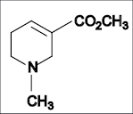

Q.15. Concerning the previous structure:
A. Nicotinic acid derivative.
B Since N atom is sp³ hybridized it is a strong base.
C. lactone functionality renders this compound sensitive to alkali.
D. Both A and B .
E. All of the above.

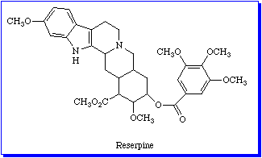

Q.16. Concerning the previous structure, all of the following are true EXCEPT:
A. The nucleus "containing alkaloid" remained after hydrolysis in basic condition is termed as ergoline.
B. Botanical source is from the root of Rauwolfia serpentine.
C. Neuroleptic agent, suicidal depression is contraindication with this drug.
D. Antihypertensive agent acts peripherally and centrally.

Part III. Unfamiliar Problems Solving
Objectives. The aim of the questions in this part is to evaluate that the student can solve familiar problems with ease and can make progress towards the solution of unfamiliar problems, and can set out reasoning and explanation in a clear and coherent manner ( marks).

Q.17. Curare
A. mixture of plant species used as arrow poison.
B. alcuronium Cl is semisynthetc analogue for Tubucurarine to increase duration of action.
C. toxicity can be reversed if first aid is done directly to hunted animal.
D. all of the above.

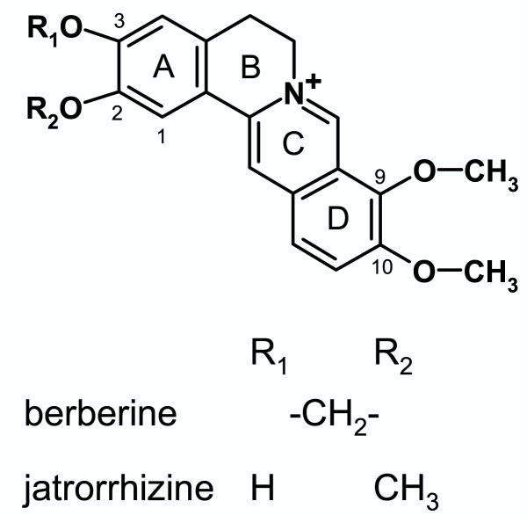

Q.18 The previous structure:
A. isoquinoline alkaloid, protoberberine type.
B. basic in nature.
C. maximum absorption obtained by introducing oral dose.
D. all of the above.

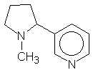

Q.19 The previous structure:
A. liquid and volatile.
B. Basicity is attributed to the N evolved in aromatic system.
C. CNS stimulant at low dose and depressant at high dose.
D. increases the tone and motility of intestinal mucosa.

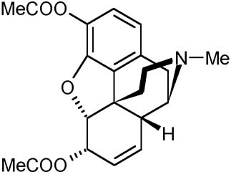

Q.20 The previous structure, all of the following are true EXCEPT:
A. Synthetic
B. Semisythetic.
C. controlled drug can be abused.

Student name:
Student number:

*********************************************************************
 | A | B | C | D | E |  | A | B | C | D | E
1 |  |  |  |  |  | 11
2 |  |  |  |  |  | 12
3 |  |  |  |  |  | 13
4 |  |  |  |  |  | 14
5 |  |  |  |  |  | 15
6 |  |  |  |  |  | 16
7 |  |  |  |  |  | 17
8 |  |  |  |  |  | 18
9 |  |  |  |  |  | 19
10 |  |  |  |  |  | 20

